JalDrishti — Project Summary
Project Overview | Version 1.0 | 9 October 2026
1. Project at a glance
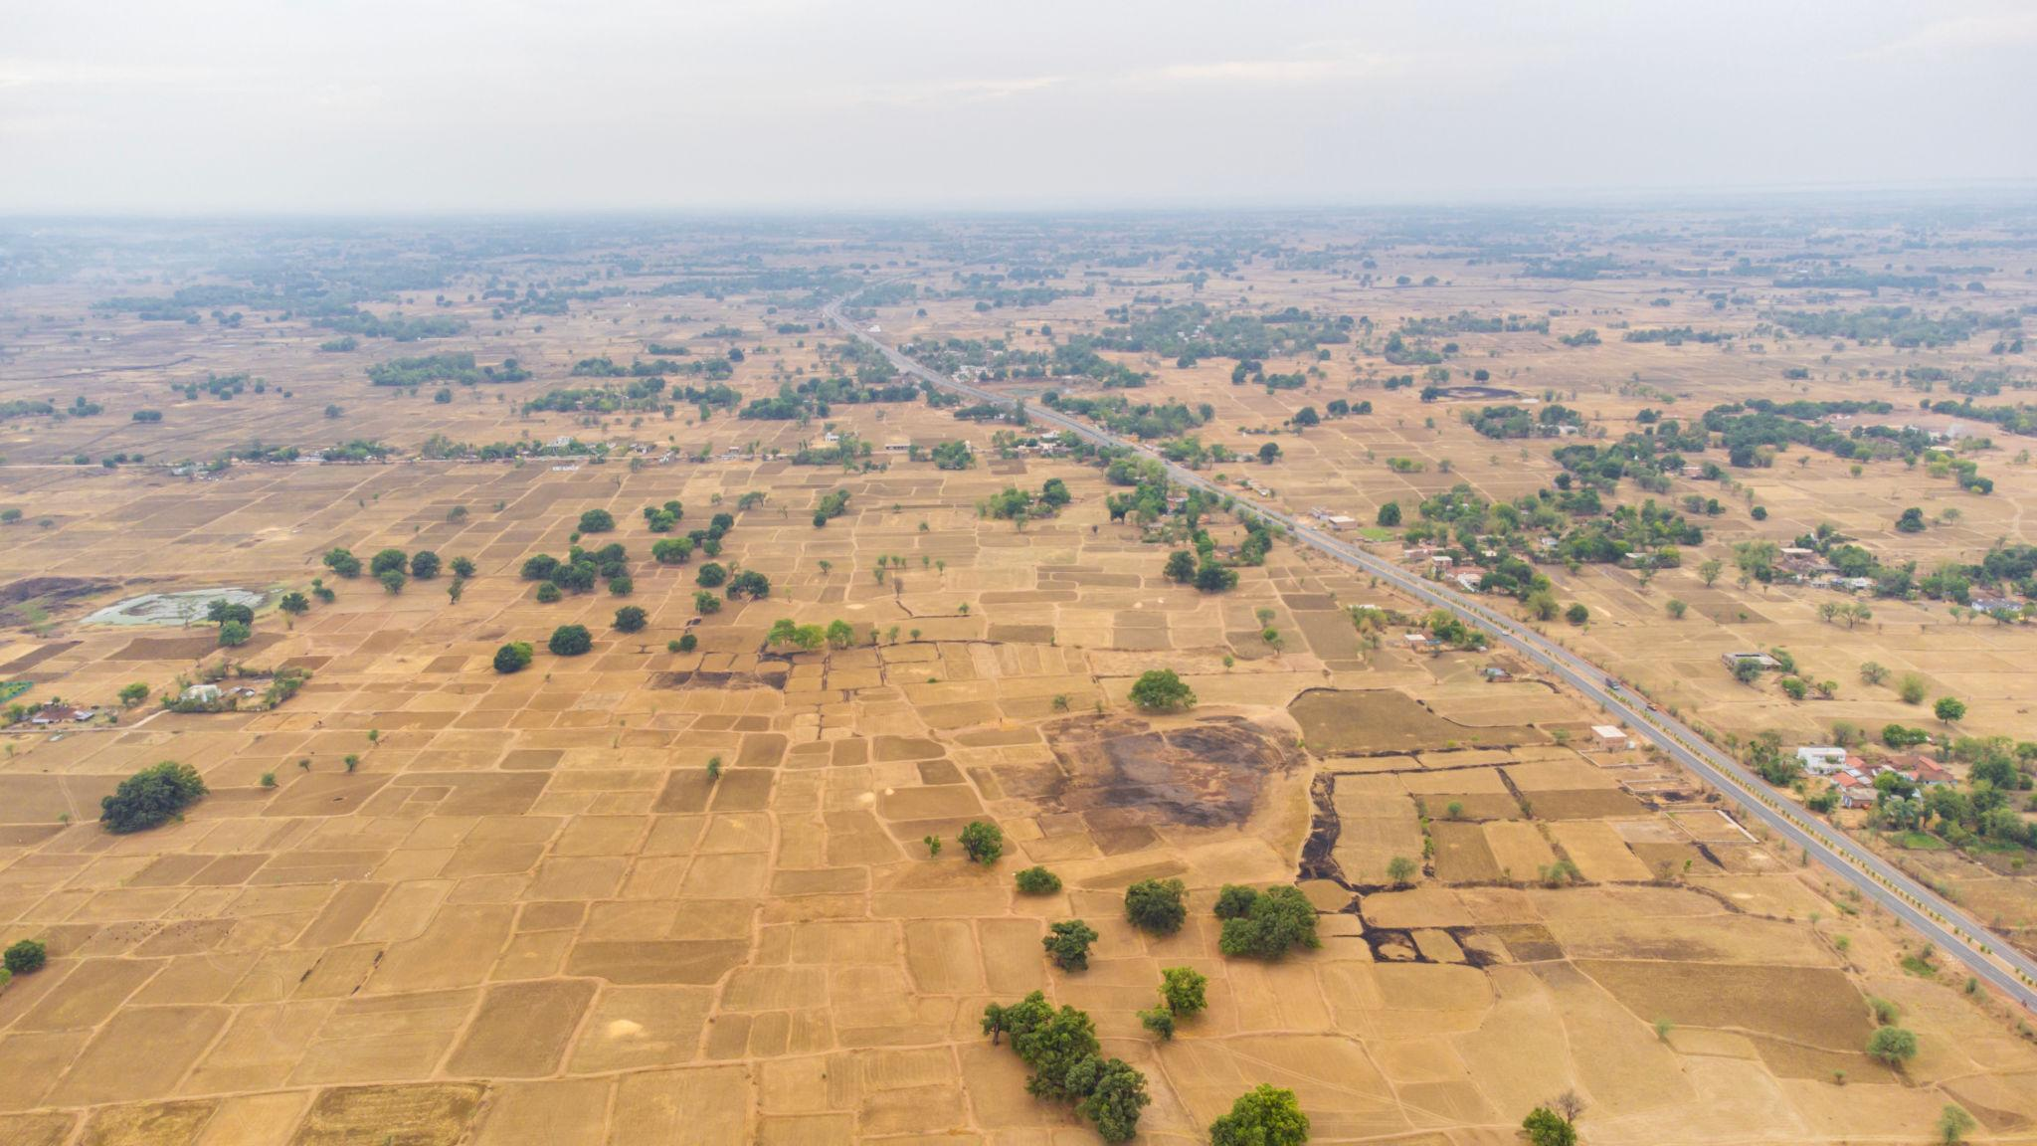
JalDrishti is a proposed satellite-assisted groundwater intelligence and early-warning platform designed to help government authorities, district administrations, and rural communities identify emerging groundwater stress, understand environmental risks, and prioritize interventions before water scarcity becomes critical.
The project aims to combine satellite observations, rainfall records, groundwater measurements, geospatial analytics, and machine learning into a unified decision-support system. Its initial proposed pilot focuses on Bundelkhand, Madhya Pradesh, a region where water availability, agricultural conditions, and rural water security are important planning concerns.
The core idea is to turn fragmented environmental data into actionable, understandable information without requiring the deployment of new field sensors as a prerequisite.
2. The problem we are solving
Groundwater stress is difficult to manage proactively because relevant information is distributed across different datasets, agencies, monitoring systems, and geographical scales.
- Delayed identification: Authorities may recognize water stress only after wells decline, crops suffer, or communities report shortages.
- Fragmented information: Rainfall, satellite observations, groundwater measurements, and agricultural indicators are not always available through one integrated workflow.
- Limited local visibility: Regional environmental datasets do not automatically provide reliable estimates for individual villages or administrative blocks.
- Reactive resource allocation: Water-conservation works and government interventions need better evidence to determine where support may be most urgent.
- Communication gaps: Technical data must be translated into understandable alerts and recommended actions for local officials and communities.
JalDrishti seeks to bridge these gaps through a common geospatial intelligence and governance-support platform.
3. What exactly are we building?
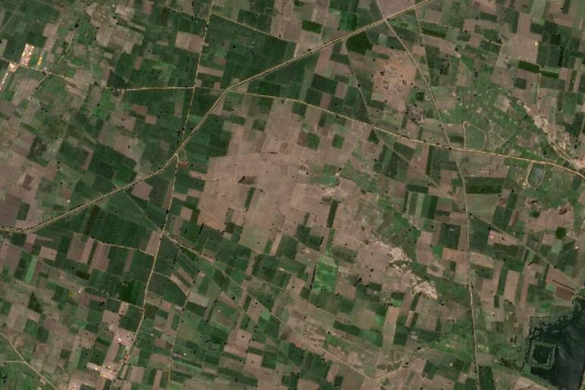
1. Satellite and environmental data integration
Collect and process relevant observations from sources such as GRACE-FO, IMD rainfall data, Sentinel-2, MODIS, SMAP, and CGWB groundwater observations, subject to data access, licensing, and technical feasibility.
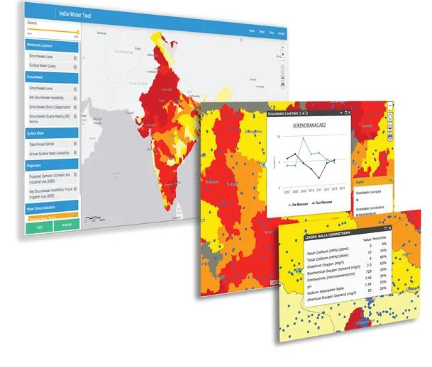
2. Groundwater-stress monitoring
Combine relevant indicators to identify areas showing potential water stress and display their trends, supporting evidence, geographical coverage, and data freshness.
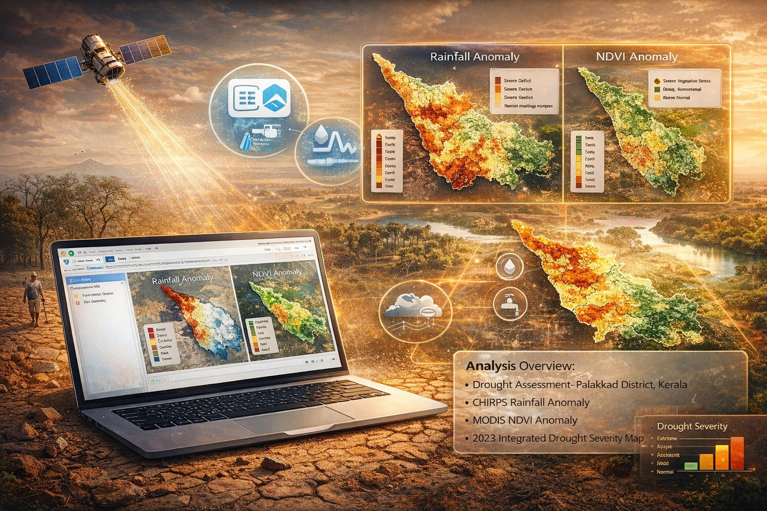
3. Risk analytics and early warning
Develop risk classifications and, after scientific validation, predictive models that help authorities anticipate worsening conditions rather than relying exclusively on retrospective reports.
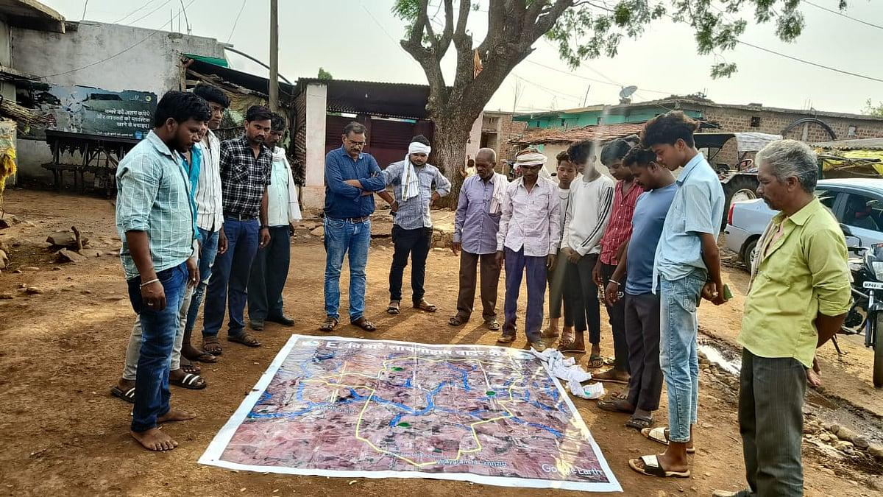
4. Governance and intervention support
Help officials identify priority locations and explore potentially relevant water-conservation and rural-development interventions, including Jal Jeevan Mission, Atal Bhujal Yojana, and MGNREGA-related works where applicable.
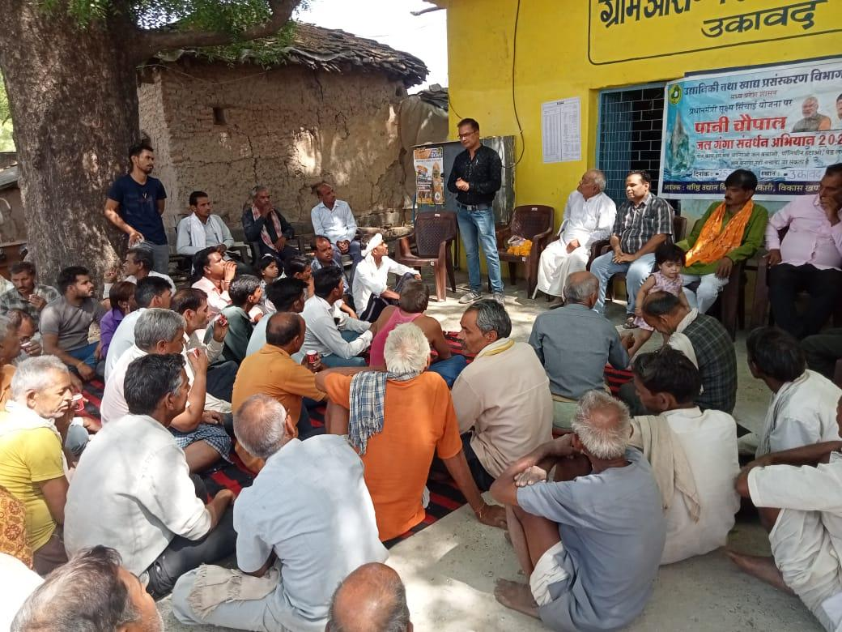
5. Localized communication
Provide understandable risk summaries and proposed Hindi-language alerts through channels such as SMS and WhatsApp, with review, delivery tracking, and escalation workflows.
4. How the system works
Data sources
Satellite observations · Rainfall · Soil moisture · Groundwater measurements
Data processing and quality control
Ingestion · Geospatial alignment · Missing-data checks · Provenance
Risk analytics
Indicators · Trends · Risk classification · Validated forecasting
JalDrishti intelligence dashboard
Maps · Historical trends · Evidence · Uncertainty · Priority locations
Human-reviewed decisions and communication
Official review · Intervention planning · Localized alerts · Outcome tracking
The platform is intended to support decisions, not autonomously declare that a village will run out of water or automatically authorize government expenditure.
5. Proposed technical architecture
Layer | Proposed technologies
Data ingestion and processing | Python, Google Earth Engine, scheduled processing jobs
Geospatial storage | PostgreSQL, PostGIS
Machine learning | Python, PyTorch, scikit-learn where appropriate
Backend and APIs | Python-based services and documented API contracts
Dashboard | Streamlit for the initial prototype
Background processing | Celery and Redis, if required by deployment scale
Communication | SMS/WhatsApp provider integration, subject to availability and compliance
Deployment | Environment-separated, monitored deployment with CI/CD, backups and access controls
These are proposed technical choices, not evidence that integrations have already been implemented or that every data source is accessible.
6. The most important scientific safeguard
JalDrishti's credibility depends on the quality of its measurements and predictions.
- GRACE-FO measures changes in total terrestrial water storage at a coarse spatial scale. It cannot independently establish precise groundwater reserves or water depth for an individual village.
- Sentinel-2, MODIS, and SMAP provide complementary environmental indicators, but combining them does not automatically produce accurate high-resolution groundwater estimates.
- The proposed Groundwater Stress Score (GSS), scored from 0–100, must be calibrated and validated against suitable ground observations before being treated as a meaningful risk measure.
- A “days-to-crisis” prediction must not be presented as authoritative until its target, assumptions, uncertainty, and predictive performance have been independently validated.
- Missing observations, stale data, model uncertainty, and conflicting indicators must be visible to users.
The correct initial approach is evidence-based monitoring first, validated prediction second, and operational early warnings only after suitable testing and human review.
7. Expected impact
Water security
Earlier visibility into areas experiencing worsening water-related conditions.
Agriculture
Better environmental context for drought and agricultural-stress planning.
Public governance
More transparent geographical prioritization of interventions.
Community awareness
More accessible, localized information for officials and rural communities.
These are intended benefits, not yet demonstrated outcomes. Actual impact must be measured during the pilot.
8. Proposed implementation roadmap
- Phase 1 — Feasibility and data audit
Confirm source availability, licensing, spatial and temporal resolution, historical coverage, and access to suitable groundwater observations.
- Phase 2 — Monitoring MVP
Build the ingestion pipeline, geospatial database, data-quality checks, initial indicators, historical trends, and map-based dashboard.
- Phase 3 — Ground-truth validation
Compare indicators with observed groundwater measurements, assess geographical bias, quantify uncertainty, and calibrate risk categories.
- Phase 4 — Predictive analytics and alerts
Introduce forecasting only where validated; test alert thresholds, Hindi communication, delivery reliability, and human approval workflows.
- Phase 5 — Pilot evaluation and expansion
Measure accuracy, usefulness, false alarms, data coverage, and operational value before expanding beyond the initial pilot area.
9. What will make JalDrishti different?
The intended differentiation is not simply using satellite imagery or machine learning. Those technologies already exist in many environmental monitoring systems.
JalDrishti aims to connect environmental evidence → localized risk assessment → accountable intervention planning → community communication → outcome tracking within one practical workflow.
Its strongest potential value is to make disparate data useful for local governance while preserving transparency about what is measured, what is inferred, and what remains uncertain.
10. Current project status and next priority
The exhaustive Product Requirements Document (PRD) and Technical Requirements Document (TRD) have been prepared as planning documents. They define the intended product, architecture, requirements, validation safeguards, risks, and implementation sequence. They do not establish that the system has been deployed, that source integrations are working, or that its predictions have been validated.
The next priority should be a small, reproducible proof of concept for a clearly defined pilot area, using accessible historical data and independently observed groundwater measurements.
In one sentence: JalDrishti is a proposed satellite-assisted groundwater intelligence platform that helps authorities monitor water-related stress, evaluate emerging risks, and prioritize evidence-based interventions—with scientific validation and human oversight at its core.
JalDrishti — Expanded Project Summary, Earlier Work & Research Gaps
JalDrishti should be positioned not as a completely new satellite-monitoring technology, but as an attempt to integrate existing groundwater and environmental research into a practical, locally actionable decision-support workflow.
The project’s research case needs to establish three things:
- What scientific methods and operational systems already exist.
- What limitations remain when those methods are applied to local groundwater-risk decisions in India.
- How JalDrishti will address those limitations without claiming that existing technologies or research are absent.
The distinction matters: satellite-based water monitoring, groundwater mapping, drought assessment, and decision-support dashboards are established areas of work. JalDrishti’s potential contribution lies in how these capabilities are combined, validated, and connected to local intervention planning.
11. Earlier works and existing systems
The following review identifies major prior work that JalDrishti must acknowledge. These systems and studies demonstrate that several of its proposed capabilities already exist independently.
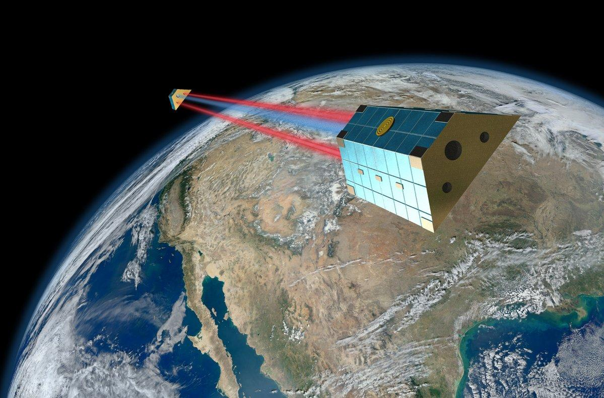
A. GRACE and GRACE-FO groundwater research
Researchers have used satellite-derived terrestrial water storage anomalies to study regional groundwater depletion and drought, including across India. A 2016 Scientific Reports study examined groundwater depletion in northwest India and demonstrated that estimated depletion rates vary with processing assumptions. A 2019 review examined GRACE data assimilation for groundwater and drought monitoring.

Scientific Reports
+1
Relevance to JalDrishti: Establishes a scientific foundation for large-scale water-storage monitoring, but not direct, precise measurement of groundwater conditions in every village.
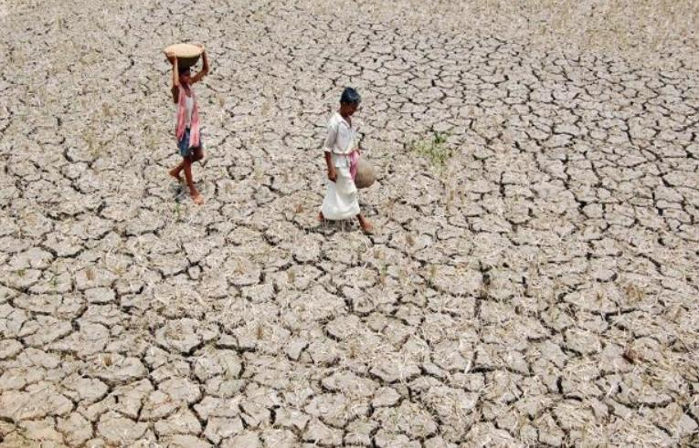
B. Groundwater prediction research in Bundelkhand
A particularly relevant 2025 study, Assessment of groundwater scenario in drought-prone semi-arid regions of the Indian subcontinent using time series decomposition and the machine learning models, examined the Bundelkhand plateau using GRACE and TerraClimate datasets, local well observations, Google Earth Engine, Prophet, and Random Forest. It reported future groundwater-storage trends through 2032. The authors also acknowledged data limitations and simplified groundwater-storage calculations that did not explicitly account for surface water and other hydrological components.

ScienceDirect
Relevance to JalDrishti: This is direct prior art in the proposed pilot region. Using GRACE, GEE, and machine learning for Bundelkhand groundwater assessment cannot, by itself, establish novelty.
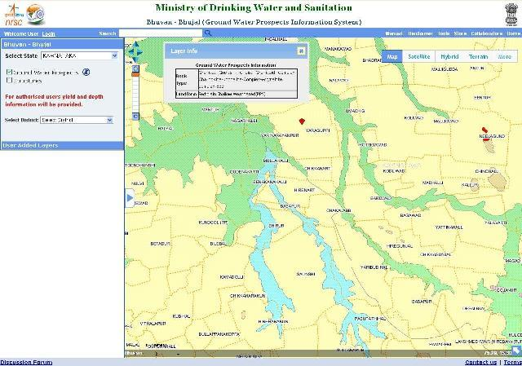
C. ISRO's Bhuvan-Bhujal and groundwater-prospect mapping
ISRO's National Remote Sensing Centre has developed nationwide groundwater-prospect maps using Indian Remote Sensing satellite data, with geological, geomorphological, structural, and groundwater-prospect information. The portal also describes groundwater-quality information and restrictions on access to some detailed layers.

Gateway to Indian Earth Observation
+1
Relevance to JalDrishti: A groundwater mapping and GIS foundation already exists. JalDrishti should investigate interoperability and complementary functionality rather than duplicate existing maps.
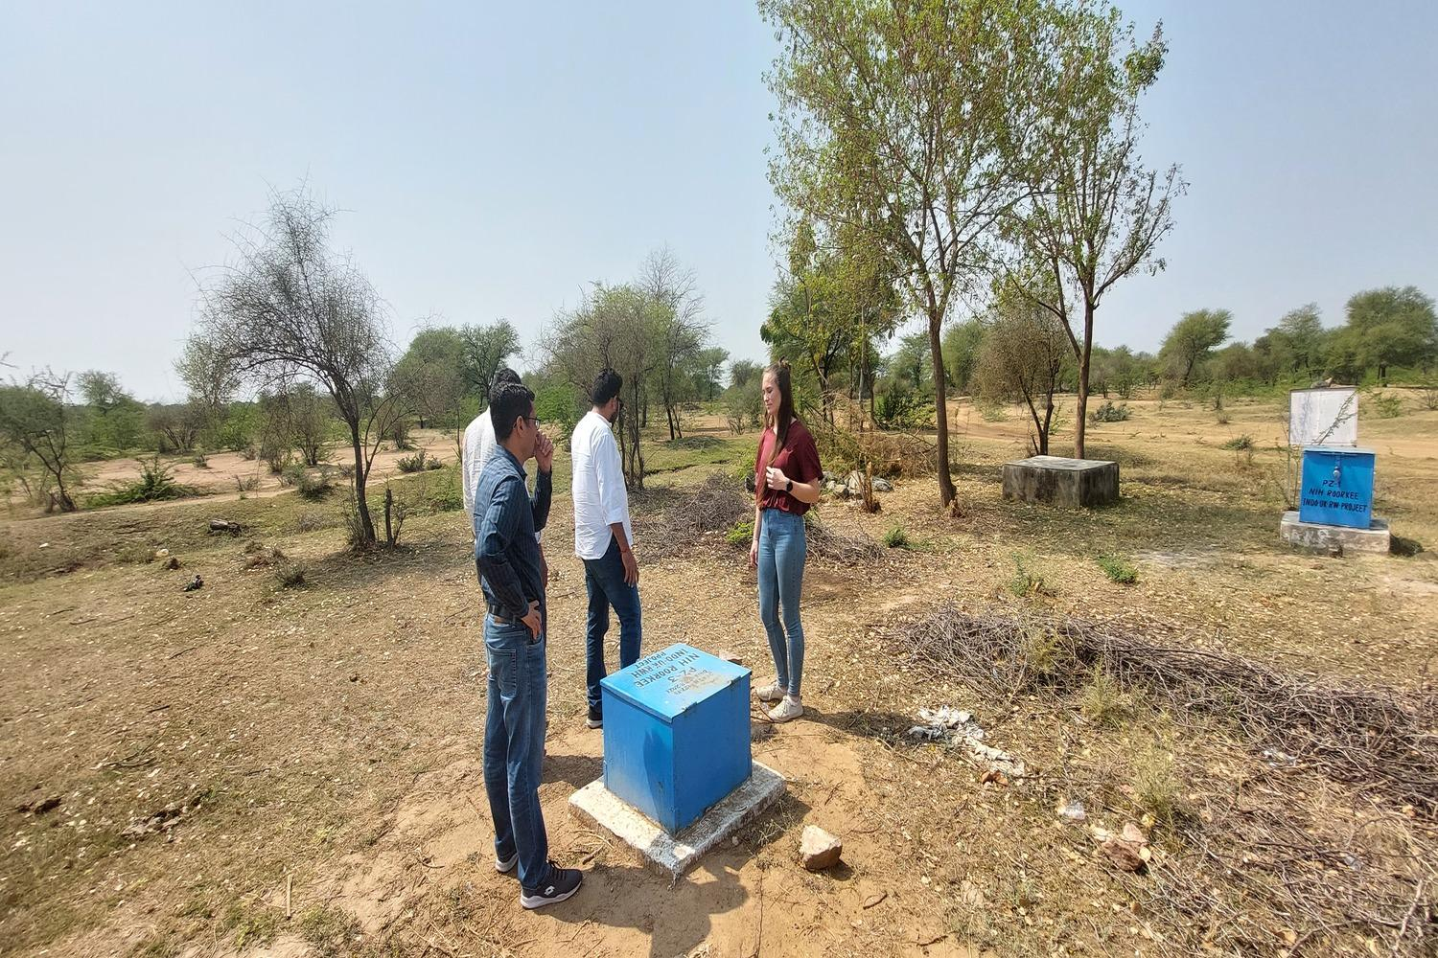
D. CGWB monitoring and India-WRIS
The Central Ground Water Board reports a network of approximately 25,000 groundwater monitoring stations, including dug wells and piezometers. It also describes digital water-level monitoring and dissemination through the Water Information Management System and India-WRIS.
CGWB
Relevance to JalDrishti: Existing ground observations are essential for calibration and verification. The practical challenge is determining which observations are accessible, sufficiently frequent, geographically representative, and suitable for the proposed model.
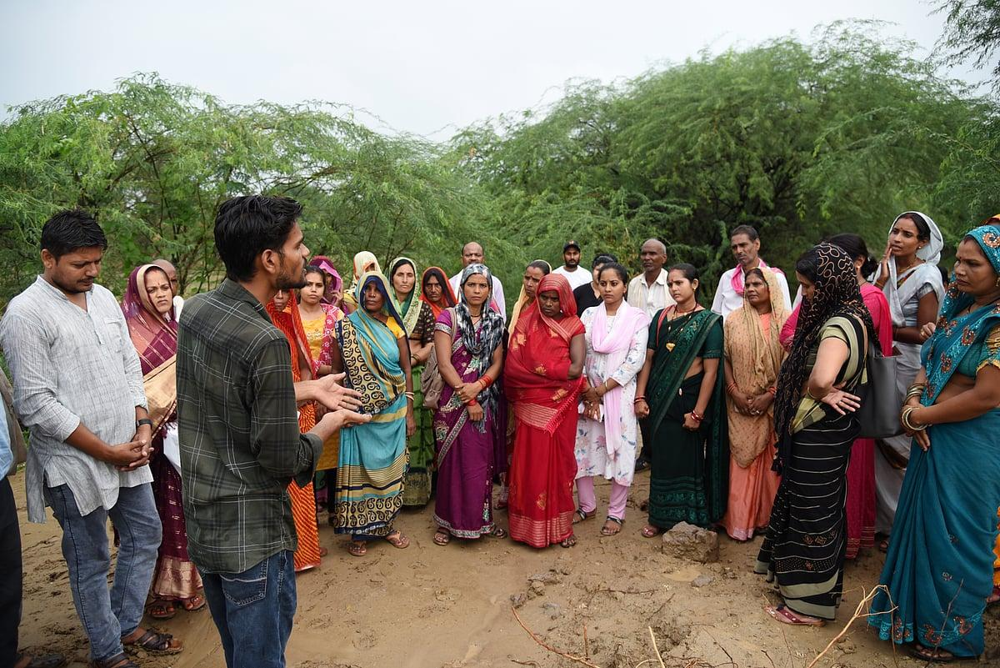
E. Atal Bhujal Yojana (Atal Jal)
Atal Jal has supported community-led groundwater monitoring, public disclosure of groundwater information, village-level water budgets, water-security plans, and demand- and supply-side interventions. Madhya Pradesh is among the participating states.

Press Information Bureau
+1
Relevance to JalDrishti: Community participation and intervention planning are already part of existing groundwater governance. The opportunity is to make environmental evidence more timely, integrated, and useful within such workflows.
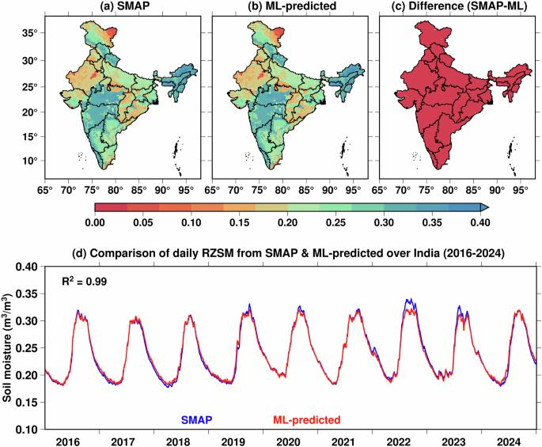
F. Machine-learning downscaling and groundwater estimation
Research reviews identify Random Forest and other machine-learning approaches as common methods for relating coarse satellite-derived storage information to finer-scale environmental predictors. They also identify persistent problems with scale mismatch, uncertainty propagation, sparse validation, and overfitting.

ScienceDirect
+1
Relevance to JalDrishti: A sophisticated model is not automatically a reliable model. Any local estimate must demonstrate that it adds predictive value beyond simpler baselines and available ground observations.
What this prior work tells us
Capability | Existing landscape | Implication for JalDrishti
Satellite-based water-storage monitoring | Established research | Build on existing methods rather than claim invention
Groundwater prospect mapping | Available through ISRO's Bhuvan-Bhujal | Integrate or complement existing mapping
Groundwater-level monitoring | CGWB and related systems | Use appropriate observations for validation
Local groundwater governance | Atal Jal and community water-security planning | Align with existing institutional processes
Bundelkhand groundwater modelling | Published research already exists | Define a more specific, measurable contribution
ML-based downscaling | Established research area | Prove added value and quantify uncertainty
Unified risk-to-action workflow | Requires further targeted investigation | Potential area for differentiation, not yet a proven research gap
12. Research gaps JalDrishti could address
These are candidate research gaps identified from the sources reviewed above. They should not be described as universally unresolved problems until a more exhaustive literature and product review has been completed.
Gap 1 · High priority
Limited translation of scientific estimates into operational decisions
Research can estimate groundwater-storage trends, while government programmes can prepare water budgets and conservation plans. JalDrishti could test whether connecting validated indicators to a transparent decision-support workflow improves the timeliness and consistency of local planning.
Research question: Does an integrated workflow improve decision quality compared with existing information sources and procedures?
Gap 2 · High priority
Insufficiently demonstrated local predictive reliability
Coarse satellite estimates and point-based groundwater measurements represent different spatial scales. Downscaling cannot automatically resolve this mismatch. JalDrishti could evaluate whether block- or village-level risk indicators are genuinely supported by observations in the selected pilot area.
ScienceDirect
+1
Research question: At what spatial scale can groundwater-risk estimates be validated with acceptable error?
Gap 3 · High priority
Uncertainty is not always carried through to the final decision
A risk score may combine uncertain satellite products, incomplete well data, model assumptions, and missing observations. JalDrishti could explicitly show confidence levels, data limitations, and alternative scenarios instead of presenting every output as equally reliable.
Research question: How does uncertainty in individual datasets affect risk classification and intervention prioritization?
Gap 4 · High priority
Short-term warning capability versus long-term trend analysis
GRACE-derived groundwater estimates are generally more suited to regional storage trends than to precise, short-term local crisis countdowns. JalDrishti could test whether more frequent rainfall, soil-moisture, evapotranspiration, and observed well-level data can support useful seasonal or short-horizon risk warnings.
ScienceDirect
+1
Research question: Which warning horizons and indicators provide reliable lead time for local authorities?
Gap 5
Integration of satellite indicators with existing groundwater records
Existing monitoring networks and portals provide valuable observations, but their access conditions, update frequency, formats, and spatial coverage must be assessed for the pilot. JalDrishti could develop a reproducible pipeline with data provenance, quality checks, and documented fallbacks.
Research question: Can the available datasets be combined reliably enough for routine local monitoring without assuming universal API access?
Gap 6
Evidence-based prioritization of water-conservation interventions
Existing schemes already support water-security plans and groundwater interventions. JalDrishti could investigate whether spatial risk indicators, local needs, feasibility, and implementation records help officials compare possible actions. The platform must not assume that a high satellite-derived risk score alone identifies the right intervention.
Research question: Do evidence-linked intervention recommendations improve prioritization, feasibility, or monitoring of outcomes?
Gap 7
Prospective evaluation in a defined pilot area
Historical model fit does not prove that a system can provide useful warnings in future seasons. JalDrishti could use time-based holdouts, comparison against simple baselines, and prospective monitoring to measure false alarms, missed risks, calibration, and decision usefulness.
Research question: Does the system perform reliably on unseen periods and across different hydrogeological conditions?
13. The critical novelty issue: what is actually new?
The 2025 Bundelkhand study is especially important because it already combines several elements in JalDrishti's proposed technical approach. Consequently, JalDrishti should not claim to be the first project to use satellite data and machine learning for groundwater assessment in Bundelkhand.
ScienceDirect
Its defensible potential novelty is a narrower, testable combination:
- A reproducible, multi-source data pipeline that documents provenance, freshness, missing data, and uncertainty.
- A validated local risk-assessment method that is explicitly compared against existing methods and simple baselines.
- A clear separation between regional water-storage anomalies, local groundwater observations, and model-derived inferences.
- Human-reviewed decision support that connects validated evidence to existing water-security planning and intervention workflows.
- Prospective measurement of whether the system improves decisions, not merely whether its dashboard works or its historical model has a high \(R^2\).
These are proposed differentiators, not confirmed novel contributions. A more complete search of Google Scholar, relevant government portals, research repositories, and deployed tools is needed before making a formal novelty claim.
14. Updated project positioning
JalDrishti's refined proposition
JalDrishti is a proposed satellite-assisted groundwater intelligence and governance-support platform for water-stressed regions of India. Building on existing Earth-observation research, CGWB monitoring, ISRO's groundwater mapping resources, and community-led water-security programmes, it aims to integrate validated environmental indicators into a transparent local risk-monitoring and intervention-planning workflow.
Its central research objective is to determine whether multi-source integration, explicit uncertainty reporting, and human-reviewed decision support can provide more reliable and actionable local groundwater-risk information than existing fragmented workflows.
Recommended proof of concept
Start with one well-defined pilot geography in Bundelkhand and compare three approaches:
- Baseline: Historical CGWB/state groundwater observations and straightforward rainfall or seasonal-trend indicators.
- Satellite-assisted monitoring: A transparent combination of available satellite and environmental indicators.
- Validated predictive model: Only if data volume and quality support it, compare suitable models against the baselines using time-based validation.
Evaluate predictive error, calibration, false alarms, missed risks, spatial coverage, data latency, and usefulness to local planning. Do not introduce a “days-to-crisis” countdown unless it passes a separately defined validation gate.
15. Sources for the research background
- Nenweli et al. (2026), Review of GRACE remote sensing applications for groundwater monitoring in water-scarce regions.
Read the review
- Assessment of groundwater scenario in drought-prone semi-arid regions of the Indian subcontinent using time series decomposition and the machine learning models (2025).
Read the Bundelkhand study
- Have GRACE satellites overestimated groundwater depletion in the Northwest India Aquifer? (2016).
Read the study
- Central Ground Water Board, Ground Water Level Monitoring.
Read the official monitoring overview
- ISRO / NRSC, Bhuvan-Bhujal.
Explore the official portal
- Government of India, Atal Bhujal Yojana implementation overview.
Read the programme update
- Li et al. (2019), Global GRACE Data Assimilation for Groundwater and Drought Monitoring: Advances and Challenges.
Read the review
Research status note: This is a targeted background review, not a systematic review of every relevant paper, patent, government platform, or commercial product. The research gaps above are promising directions for investigation, not proof that no comparable solution exists.

